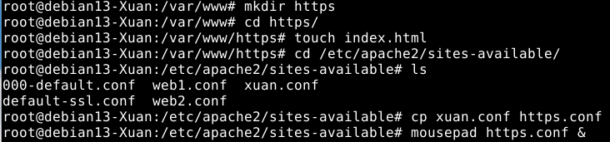
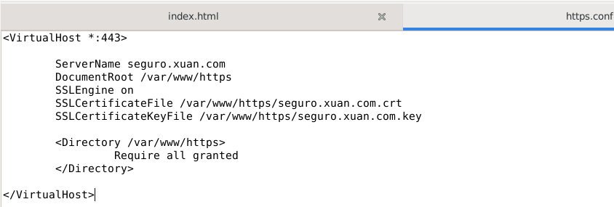
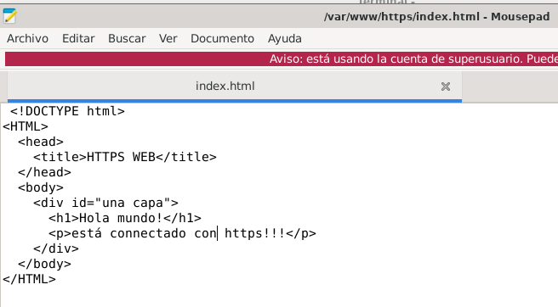
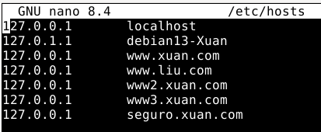

root@debian13-Xuan:/var/www/https# openssl req -x509 -nodes -days 365 -newkey rsa:2048 -keyout seguro.xuan.com.key -out seguro.xuan.com.crt
..+......+...+++++++++++++++++++++++++++++++++++++++*..+....+.........+........+..........+...+......+......+...+++++++++++++++++++++++++++++++++++++++*....+...+...+.....+.+.........+............+...+..+.........+...+.......+...+...+...+..............+...+............+...+..................+......+...+.........................+...+..+......+...................+...+............+..+....+.........+.....+.+.....+.+.....+.........+.........+.......+.....+.........+.+...+..+....+.....+.......+.....+....+...++++++
..+..+...+.......+..+++++++++++++++++++++++++++++++++++++++*.+....+..+....+...+..+...+......+.+...........+.........+...+...+.......+.....+.+..+...+............+...+....+..+++++++++++++++++++++++++++++++++++++++*...+...+.........+..+...+.+..+............+.............+.....+...+......+.+...+......+..............+.+........+.......+...+...+...+..+...............+...............+...+.........+...+.......+..+...............+.............+..+.........+...............+......+...+...+.........+....+..+..................+....+..+.+..+.......+.....+.........+....+...+............+........+..........+............+..+................+........+....+.....+.+.....+.......+...+......+........+...+.......+....................+...+.......+........+...+.......+..+.+..............+............+.+...+.........+..................+...+.....++++++
-----
You are about to be asked to enter information that will be incorporated
into your certificate request.
What you are about to enter is what is called a Distinguished Name or a DN.
There are quite a few fields but you can leave some blank
For some fields there will be a default value,
If you enter '.', the field will be left blank.
-----
Country Name (2 letter code) [AU]:xuan
String too long, must be at most 2 bytes long
Country Name (2 letter code) [AU]:xl
State or Province Name (full name) [Some-State]:Madrid
Locality Name (eg, city) []:Madrid
Organization Name (eg, company) [Internet Widgits Pty Ltd]:xuan
Organizational Unit Name (eg, section) []:xuan
Common Name (e.g. server FQDN or YOUR name) []:xuan
Email Address []:abc123@emial.com
